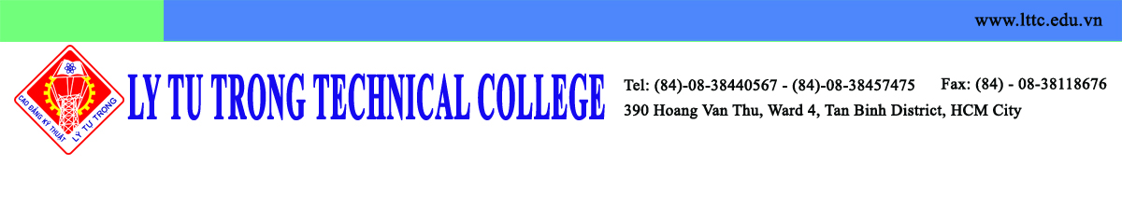

Cardiff Metropolitan University
200 Western Avenue
Cardiff, South Glamorgan
CF5 2YB, United Kingdom

Thursday 25th February 2016

Dear Mr. Chris Kelly,

On behalf of Ly Tu Trong Technical College I am very honored to welcome you at our campus. I hereby confirm that the meeting will take place on Monday 29th February 2016 due to your previous letter.

Your visit is expected to promote the cooperation between Cardiff Metropolitan University and Ly Tu Trong Technical College. This will open a great opportunities for students to gain valuable experiences at one of the best universities in United Kingdom while integrating into the unique English language and culture.

I would like to thank you for your kind cooperation and I am looking forward to meeting you on the scheduled date.
Sincerely,

Pham Huu Loc
Rector
Ly Tu Trong Technical College

